NAME: RAFEETH ARIFA S
REG NO: 2019504049
TITLE: HOME AUTOMATION
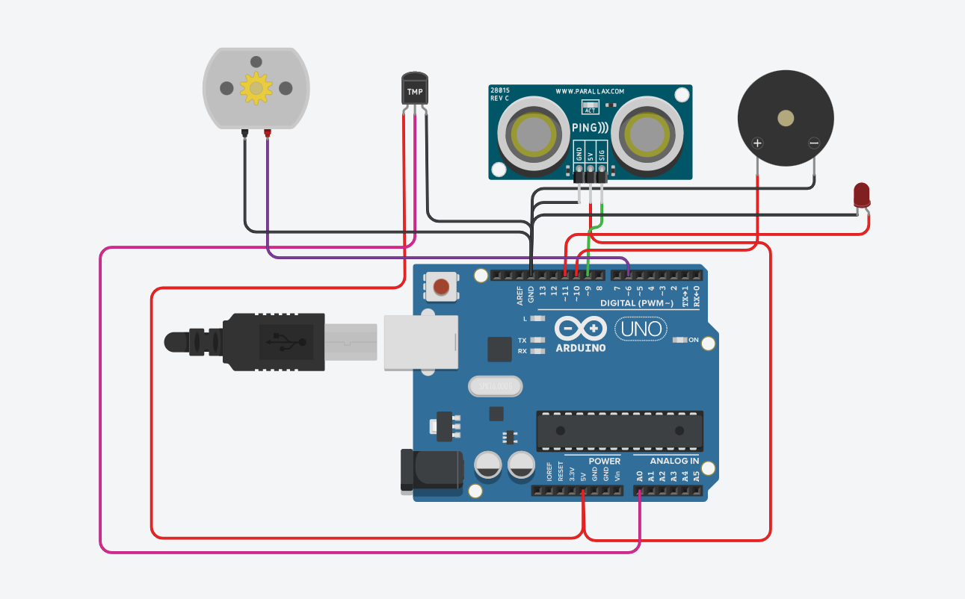
CODE:
//Home Automation with two sensors namely Ultrasonic and Temperature sensor
long readUltrasonicDistance(int triggerPin, int echoPin)
{
pinMode(triggerPin, OUTPUT); // Clear the trigger
digitalWrite(triggerPin, LOW);
delayMicroseconds(2);
// Sets the trigger pin to HIGH state for 10 microseconds
digitalWrite(triggerPin, HIGH);
delayMicroseconds(10);
digitalWrite(triggerPin, LOW);
pinMode(echoPin, INPUT);
// Reads the echo pin, and returns the sound wave travel time in microseconds
return pulseIn(echoPin, HIGH);
}

void setup()
{
pinMode(LED_BUILTIN, OUTPUT);
pinMode(10, OUTPUT);
pinMode(11, OUTPUT);
pinMode(6,OUTPUT);
pinMode(A0,INPUT);
Serial.begin(9600);
}

void loop()
{
if (0.01723 * readUltrasonicDistance(9, 9) > 60) {
digitalWrite(LED_BUILTIN, HIGH);
digitalWrite(11,HIGH);
tone(10,100,1000);
delay(1000);
} else {
digitalWrite(LED_BUILTIN, LOW);
digitalWrite(11,LOW);
delay(1000);
}
int value=analogRead(A0);
int temp = (value *5.0*100.0)/1024.0;
Serial.println(temp);
delay(1000);
if (temp>90) {
digitalWrite(6,HIGH); //above 40C fan will spin
delay(1000);
} else {
digitalWrite(6,LOW);
delay(1000);
}
}

